Using autoencoders to detect unusual activity in IOT networks

By
By Mohamed Ibrahim

Submitted to
The University of Roehampton

In partial fulfilment of the requirements
for the degree of
BACHELOR OF SCIENCE/ENGINEERING IN software engineering

Declaration

I hereby certify that this report constitutes my own work, that where the language of others is used, quotation marks so indicate, and that appropriate credit is given where I have used the language, ideas, expressions, or writings of others.

I declare that this report describes the original work that has not been previously presented for the award of any other degree of any other institution.
Signed (apply signature below)
Mohamed Ibrahim
Date: 29/01/2026

Acknowledgements

Here it is customary to thank the people who have supported this work and your studies in general. It is up to you who you thank!
I would like to express my sincere thanks to my supervisor for their ongoing guidance, insightful feedback, and unwavering support, all of which played a key role in shaping the direction and enhancing the quality of this project. I am also grateful to the teaching team and my peers for the many valuable conversations and suggestions, especially during the design and evaluation phases. Lastly, I deeply appreciate my family and friends for their patience and encouragement throughout this journey.

Abstract
GUIDANCE: Up to three hundred words
A summary of your project to include the problem, the main literature reviewed, your implementation and your findings.
Write this after you have finished the entire report!

Detecting unusual activity in network traffic is a key sign that an Internet of Things (IoT) device might be formed. However, spotting these anomalies accurately is difficult due to the wide range of devices, the fast pace of emerging threats and the lack of labelled data is known for attacks. This project explores an unsupervised approach to anomaly detection using deep autoencoders, which learn the typical patterns of normal IoT network traffic and flag anything that does not fit based on reconstruction errors. Building on existing research and publicly available datasets, the project delivers a reproducible pipeline that covers everything from data preprocessing and a feature extraction to model training and anomaly scoring. The systems performance is compared with a traditional baseline and evaluated using standard metrics like precision, recall, F1-score, and PR-AUC. Special attention is given to how thresholds are set and how often false positives occur. The result is a working prototype, along with a practical evaluation framework that examines both the potential and the limitations of using autoencoders for monitoring IoT networks.
Table of Contents

Table of Contents
Table of Contents 6
List of figures 8
List of Tables 8
1. Introduction 9
Problem Statement and/or Research question 9
Aims 10
Objectives 10
2. Background and Context 11
Background 11
Summary of relevant published work (Literature review) 11
Problem landscape: why IoT anomaly detection is difficult 12
Source / Tool 17
Key contribution 17
Relevance to project 17
Limitations 17
N- Balot [1] 17
Used deep autoencoders to detect IoT botnet activity 17
Validates the use of autoencoders for network anomalies 17
Lab – based data; may not generalise to real world networks 17
Isolation forest 17
Unsupervised baseline model for anomaly detection 17
Acts as a benchmark for evaluating the autoencoder 17
Limited when modelling non linear or complex behaviours 17
IoT-23 [2] 17
Public dataset with benign and malicious IoT traffic 17
Used for training, validation and reproducibility 17
Synthetic; may not reflect full network diversity 17
AWS/Microsoft/Cisco 17
Commercial IoT anomaly detection platforms 17
Shows industry use of behavioural – based detection 17
Closed-source; lack transparency for academic evaluation 17
Zeek / Suricata 17
Open-source tools for traffic inspection and logging 17
Useful for extracting network features for modelling 17
Not ML-based; require integration with anomaly detection logic 17
PR vs ROC research 17
Emphasises PR – AUC for imbalanced datasets 17
Informs metric selection for evaluating model performance 17
Requires contextual interpretation of results 17
3. Tools and Methods 18
4. Requirements/Specifications 23
5. Solution design 26
6. Solution implementation 29
7. Solution testing/ evaluation 31
8. Discussion 32
9. Conclusion 32
Summary 32
Recommendations for further work 32
Reflection 32
10. References 33
11. Appendices 34

List of figures

List of Tables

Introduction

As the number of Internet of Things (IoT) devices continues to grow in both homes and organisations, networks are becoming larger and more complex – and so is the potential for cyberattacks. Many IoT devices are deployed with minimal security measures, rarely receive updates and can be easily exploited for malicious purposes like scanning, joining botnets or launching denial of service attacks.
What makes the situation even more challenging is that diverse types of IoT devices produce different traffic patterns and there is often a lack of labelled data that clearly finds what an attack looks like. This makes it hard to reliably detect when a device has been compromised.
This project investigates whether autoencoder-based anomaly detection can help address that challenge. The goal is to learn what normal network behaviour looks like for IoT devices and use reconstruction errors from the autoencoder to flag anything that appears abnormal or suspicious.

Problem Statement and/or Research question
Detecting unusual network behaviour from IoT devices is tricky because these environments are made up of many distinct types of devices, and there is usually not enough labelled data to train supervised intrusion detection systems. As a result, current security monitoring systems might either miss new kinds of attacks or generate too many false alerts. Both individuals and organisations are affected – compromised devices can lead to privacy breaches, service interruptions and potentially even larger – scale attacks if those devices are used as part of a botnet or other malicious operation. This issue shows up in real world IoT setups, especially in environments where devices are unmanaged or usage patterns often change. Since these devices generate constant traffic, unusual behaviour can be hard to spot and easy to overlook. The sooner suspicious activity is found the more damage can be prevented. A smart anomaly detection system could catch threats early, even in situations where there’s no labelled attack data to work with – making networks more secure and resilient overall.

Research question
How effectively can an autoencoder based anomaly detection model spot unusual behaviour in IoT network traffic – and can it do so with good accuracy and a small number of false alarms when evaluated on standard benchmark datasets?

Aims
Develop an anomaly detection system that learns and models normal IoT network activity using an autoencoder. Build and evaluate the model on real IoT network traffic data and compare its performance against a traditional anomaly detection approach. Deliver a prototype that is easy to reproduce and well documented along with an evidence-based evaluation plan and a discussion of the practical challenges involved in deploying the system.

Objectives
Conduct a review of existing research on IoT intrusion detection and autoencoder based anomaly detection to support and justify the chosen approach. Choose a proper public dataset holding IoT network traffic and define how it will be pre-processed and transformed for training and evaluating the model. Implement both a baseline anomaly detection method and an autoencoder, using reconstruction error to score and name anomalies. Set a threshold for detecting anomalies and evaluate performance using metrics like precison, recall, F1-score, and PR-AUXC – including a detailed look at false positives and false negatives. Document all key design decisions, highlight potential risks, and consider any ethical or professional implications ensuring the project stays aligned with the expected report structure and assessment guidelines.

Background and Context

Background
Internet of things (IoT) devices have become a routine part of daily life, now widely used in homes, businesses, and industrial settings. They power everything from environmental sensing and access control to surveillance systems and automation tools. Despite their growing presence, many of these devices are deployed with minimal security protections. They are often poorly maintained, rarely updated and tend to communicate in predictable ways. These weaknesses make them attractive targets for cybercriminals, especially those deploying malware that spreads by scanning for exposed services, exploiting default credentials, or enlisting devices into botnets.
One well known example is the Mirai botnet which was analysed in a landmark study presented at USENIX security. It proved how large numbers of vulnerable IoT devices could be hijacked and used to launch powerful distributed denial of service (DDoS) attacks.
To defend against such threats, many organisations rely on network-based monitoring. This approach is appealing because it avoids the need to install software agents directly on resource constrained devices and can instead check traffic patterns across the entire network. Solutions like AWS IoT device defender and Microsoft defender for IoT use machine learning to set up normal device behaviour and raise alerts when anomalies occur. These systems typically combine techniques such as passive monitoring, behaviour analysis, and rule-based alerting to help security teams detect suspicious activity.
This project fits into the space of network-based anomaly detection, particularly for IoT environments where devices behave differently and traffic patterns are unpredictable. One of the main challenges in this area is finding truly suspicious behaviour without being misled by harmless variations. Since labelled data showing exactly what constitutes an attack is often unavailable, especially in real world developments, the focus is increasingly shifting to unsupervised and semi supervised methods. These techniques try to learn what normal behaviour looks like, then flag deviations using anomaly scores – making them well suited for dynamic, label scarce environments like IoT.

Summary of relevant published work (Literature review)

Problem landscape: why IoT anomaly detection is difficult.

Detecting anomalies in IoT networks is particularly challenging due to three major factors:
Device heterogeneity:
IoT environments typically consist of a wide range of devices – each using different communication protocols, generating varying traffic volumes, and showing diverse behavioural patterns. A detection model trained on one device type may not perform well on another unless its features are carefully engineered or tailored individually for each device.
Limited data and labelling constraints:
Supervised intrusion detection relies on access to accurately labelled datasets having both benign and malicious traffic. However, in real-world deployments, obtaining such ground-truth labels is rare. Even public datasets may reflect controlled lab conditions that do not fully capture the complexity and variability of live networks.
Operational usability:
For an anomaly detection system to be useful in practice, it must minimise false positives – alerts should be actionable and not overwhelm the user. A detector that often raises false alarms becomes untrustworthy, even if it shows superior performance metrics in evaluation.
Multiple survey studies on IoT anomaly detection stress that it is enough to simply compare algorithms. Effective research in this area must consider the realism of the datasets used, how evaluations are conducted, and how well models manage real world issues like concept drift when the behaviour of devices changes over time. One broad survey reviewed a variety of anomaly detection techniques and showed how the definition of anomaly changes depending on the context. Another survey focused on AI – based techniques also highlighted methodological challenges and open research questions.
Implications for this project:
To ensure relevance and rigour, the method must include:
- A clear and justified choice of dataset
- Strong baseline models for comparison
- Evaluation metrics that account for class imbalance and
- A detailed analysis of false positives and false negatives – not just overall performance scores
- A detailed analysis of false positives and false negatives not just overall performance scores

Intrusion detection approaches for IoT traffic
Intrusion detection techniques for IoT can be broadly categorised into three groups:
- Signature or rule-based intrusion detection systems (IDS):
These systems detect known threats by matching traffic patterns to predefined rules or signatures. While effective for finding familiar attacks and policy violations, they struggle to detect new or evolving threats, especially if the traffic is encrypted or if behavioural changes occur slowly over time. They also need constant rule updates and tend to be less adaptable to device specific behaviours.
- Supervised Machine Learning:
When high quality, labelled datasets are available, supervised models can achieve impressive results. However, they often overfit to the specific characteristics of the dataset they were trained on – such as network setup or background traffic – and may not generalise well to unseen attack types or new device behaviours. Given the scarcity of comprehensive labelled attack data in IoT environments, relying solely on supervised approaches can be fragile and ineffective.
- Unsupervised and Semi supervised anomaly detection:
These techniques aim to learn what constitutes normal behaviour from mostly or entirely unlabelled data and then find deviations. This makes them suitable for real world IoT environments where labelled attack data is limited. However, they also come with challenges:
Defining clean training data: if the training data includes undetected attacks, the model may inadvertently learn to treat malicious behaviour as normal.
Setting thresholds: choosing the right threshold to distinguish normal from abnormal behaviour involves trade-offs – too low and the system may trigger too many alerts; too high and it may miss genuine threats.
Ensuring anomalies are meaningful: not all rare behaviours are threats – some may be benign but infrequent.
Critical comparison:
Anomaly detection holds strong appeal in IoT security because it reduces reliance on labelled data and can potentially detect unknown or novel threats. However, without careful calibration and evaluation, these systems risk generating excessive false positives and may not be useful in operational settings.

Autoencoders as anomaly detectors: mechanism and motivation
Autoencoders are a type of neutral network designed to learn compressed representations of input data and reconstruct it as accurately as possible. For anomaly detection, they are typically trained on normal traffic. The key idea is:
- Normal data is reconstructed with low error.
- Anomalous data – which differs from what the model has seen – results in higher reconstruction error.
Formally, given an input feature vector x in Red, the autoencoder attempts to reconstruct it as x^. The anomaly score s(x) is calculated as the average reconstruction error across features:
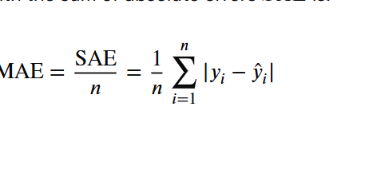
A sample is flagged as anomalous if its score exceeds a chosen threshold T.
A foundational work in this area is in the N-Ballot paper (Network based Detection of IoT Botnet attacks using deep autoencoders), which proved that autoencoders could effectively name botnet related anomalies in IoT devices. The paper made two significant contributions:
- it showed that autoencoders could detect malicious activity quickly, and
- it introduced the idea of extracting “behaviour snapshots” – short term summaries of network behaviour suitable for model input.

Strengths of the autoencoder approach, as reported in the literature:
- works well even when labelled attack data is scare – a common situation in IoT networks.
- learns complex, nonlinear patterns in traffic data, outperforming simpler linear techniques like PCA.
- produces a continuous anomaly score, which supports fine tuning via thresholds.

Key limitations and risks:
Contamination in training data: if training data includes some attack traffic, the model may mistakenly learn to treat it as normal, making anomalies harder to detect.
Threshold sensitivity: a well performing reconstruction model does not automatically guarantee a usable anomaly threshold – tuning is essential.
Generalisation: models trained in one environment may not perform well in others due to differences in devices or network configurations – an issue repeatedly noted in survey papers
Explainability: reconstruction error alone is not always intuitive or helpful for analysts trying to understand why a sample was flagged – added tools may be needed to provide insight.
Implications for this project:
The literature clearly supports the use of autoencoders for IoT anomaly detection. However, this project must also address real world concerns such as ensuring clean training data, selecting right thresholds and evaluating the model’s generalisability to different environments.

Feature engineering: packets vs flows vs logs
When it comes to detecting anomalies in IoT network traffic, the way the data is being represented is just as important as the machine learning model being used. Feature engineering – the process of selecting and structuring input data – plays a critical role in deciding the success of any anomaly detection pipeline.
Packet level modelling captures extremely fine-grained information. Every bit of data transmitted across the network is kept, which allows models to learn from very subtle behavioural patterns. However, this level of detail comes at a cost: packet – level data is massive in volume, making it difficult to scale across large or long running networks. Furthermore, widespread use of encryption in modern IoT communication protocols limits the visibility and utility of raw packet data, especially for payload inspection.
To balance granularity and scalability many researchers turn to flow level features. These are summaries of traffic between two endpoints over a period or a session. Common features include the number of bytes and packets sent, connection duration and inter arrival times. Flow based representations are compact, easier to process and often used in public datasets. They are well suited for detecting behaviours such as scanning activity, botnet command and control periodicity and large-scale data exfiltration attempts.
An added layer of insight comes from protocol-level logs, which provide semantic context to network activity. Logs from DNS, HTTP, or TLS protocols can reveal domain queries, HTTP methods, and certificate attributes, respectively. This higher-level information often helps in distinguishing legitimate user activity from potentially malicious behaviour. However, the usefulness of such logs is limited by encryption and the need for reliable parsing tools.
Tools like Zeek are commonly used in academic and enterprise settings to extract structured, meaningful logs from network traffic. Zeek allows researchers to generate consistent and reproducible features suitable for downstream analytics, supporting both flow level summaries and protocol-specific logs.
Key takeaway:
Effective anomaly detection does not begin with deep learning; it begins with a solid, end to end pipeline. This includes stable and meaningful feature engineering, correct data scaling, careful dataset portioning, and reproducible evaluation – all of which are essential for credible research and practical deployments.

Benchmark datasets: value and pitfalls.
Public datasets are a cornerstone of empirical research in IoT anomaly detection. They allow for benchmarking, reproducibility, and comparative evaluation of different models. However, they are not without limitations and critical reflection on their strengths and weaknesses is essential.
Two commonly referenced datasets in this space are:
IoT-23: this is a labelled dataset that includes both benign and malicious traffic from IoT devices. Malicious behaviours were generated using real malware samples running on IoT devices in a lab making the data realistic in terms of traffic shape and protocol use.
Bot-IoT: developed in a controlled cyber range environment, this dataset includes a diverse range of attacks such as Dados, data theft, and port scanning. The traffic is labelled and provided in several formats (e.g., PCAP, CSV), with metadata that categorises diverse types of attacks.
Advantages of using public datasets:
- They provide reliable ground truth labels, which are critical for evaluating supervised and semi supervised models.
- They enable researchers to compare their work with earlier studies on the same data.
- They avoid ethical complications related to capturing real world user data such as privacy concerns or compliance requirements.

Limitations to be aware of:
Capture bias: since the data is collected in lab environments, it may not accurately reflect the variability and noise of real world IoT networks.
Imbalanced class distribution: some datasets have a higher concentration of attack traffic that would be found in real settings. This can lead to overfitting and poor generalisation.
Temporal relevance: as IoT devices and threats evolve, older datasets may become less representative of modern behaviour.
Project implications:
This project will use one or more of these datasets for model training and evaluation, but the findings will be carefully framed as performance on benchmark data – not as definitive evidence of real-world effectiveness. Generalisability, dataset bias, and limitations will be clearly discussed.

Source / Tool | Key contribution | Relevance to project | Limitations
N- Balot [1] | Used deep autoencoders to detect IoT botnet activity | Validates the use of autoencoders for network anomalies | Lab – based data; may not generalise to real world networks
Isolation forest | Unsupervised baseline model for anomaly detection | Acts as a benchmark for evaluating the autoencoder | Limited when modelling nonlinear or complex behaviours
IoT-23 [2] | Public dataset with benign and malicious IoT traffic | Used for training, validation, and reproducibility | Synthetic; may not reflect full network diversity
AWS/Microsoft/Cisco | Commercial IoT anomaly detection platforms | Shows industry use of behavioural – based detection | Closed source; lack transparency for academic evaluation
Zeek / Suricata | Open-source tools for traffic inspection and logging | Useful for extracting network features for modelling | Not ML-based; require integration with anomaly detection logic
PR vs ROC research | Emphasises PR – AUC for imbalanced datasets | Informs metric selection for evaluating model performance | Requires contextual interpretation of results

Evaluating an anomaly detection model requires comparison with a reliable baseline. Isolation forest, a widely used unsupervised method, finds outliers by how easily they can be separated using random splits. It is lightweight and interpretable, making it a strong benchmark. This project uses it to assess whether improvements from the autoencoder are meaningful and not just due to added complexity.
IoT datasets are often highly imbalanced, with very few attack samples. Therefore, accuracy alone is not a reliable metric. Instead, precision, recall, F1-score, and particularly PR-AUC are more informative. Threshold choice also plays a crucial role in real-world usability; a poorly calibrated threshold can lead to excessive false alarms. This project will address this through validation – based tuning.
While commercial tools like AWS and Cisco offer anomaly detection, they lack transparency. Open-source tools like Zeek and Suricata offer flexibility but require integration. This project fills that gap with a reproducible, open prototype.

Tools and Methods
This section explains how the project will be undertaken and what factors influence key decisions. It describes the tools, algorithms, data handling approach, and evaluation strategy used to create the project artefact. It also justifies choices by referencing findings from the literature and competitor review, and considers legal, ethical, and professional implications of the chosen approach.
Rational for the technical tools selected.
Programming environment
The implementation will be developed in Python due to its mature ecosystem for data science and machine learning enabling rapid prototyping and reproducibility. The project will use:
NumPy/Pandas for data manipulation and cleaning
Scikit learn for preprocessing (scaling, splitting) and classical anomaly detection baselines.
TensorFlow/Keras or PyTorch to implement the autoencoder model.
Why suitable: These tools support reproducible experimentation (fixed random seeds, consistent pipelines) and provide reliable implementations of baselines for comparison, which strengthens the validity of evaluation.
Data processing and feature handling
IoT intrusion datasets are typically provided as network flow features or can be converted into such features. Flow features are practical because they are compact, scalable, and more realistic for monitoring than raw packet payloads. The project will standardise numeric features (e.g., z-score normalisation) and manage missing values consistently to reduce training instability.
Alternatives considered: packet level deep learning was considered but rejected due to complexity, high computational cost and reduced practicality under encryption and diverse protocols for a final year project scope.
Baseline and model choices
To ensure claims are evidence based, the autoencoder will be compared to at least one classical anomaly detection baseline (e.g. Isolation Forest or one class SVM). This helps prove whether performance improvements come from representation learning rather than only preprocessing choices.
Experiment tracking and reproducibility.
Experiments will be tracked using:
- Git/GitHub for version control and evidence of progress
- A structured experiment log (configuration file and run outputs) to record dataset versions, splits, hyperparameters and evaluation metrics.
This directly supports the requirement for clear technical progress and a practical project plan.

Rationale for the research methods used.
Overall approach
This project uses an experimental design and evaluates method: a working anomaly detection artefact is designed, implemented, and evaluated on benchmark IoT traffic data. The approach fits the project goals because the outcome is not only a model, but a complete pipeline (preprocessing > modelling > scoring > evaluation) that can be accessed against aims and goals.
Model development method (ML experimentation)
The core research method is controlled machine learning experimentation:
- Define the dataset and feature set.
- Preprocess data consistently (scaling, splits)
- Train the autoencoder on normal or mostly normal data
- Generate anomaly scores using reconstruction error.
- Choose/calibrate a threshold using validation behaviour.
- Evaluate on held-out test data and compare against baselines.
Evaluation method
Evaluation will be conducted using standard classification/anomaly metrics (precison, recall, F1-score, PR-AUC) and supported with qualitative error analysis (false positives / false negatives). This is important because operational usefulness depends heavily on false alarms, not only headline accuracy.
Why this method is suitable: The module marking criteria expects a clear rational for methods an evidence-based design and an evaluation plan aligned with the problem definition.
Project management and product lifecycle.
The project is managed by using an Agile – style lifecycle, with tasks are organised into sprints and tracked using a project management tool (e.g., GitHub projects or Trello). This supports ongoing progress monitoring and allows priorities to be adjusted based on early technical findings.
Part 1: dataset selection + preprocessing pipeline + baseline model proof of concept
Part 2: autoencoder implementation + anomaly scoring method.
Part 3: threshold calibration + evaluation harness + metric reporting
Part 4: refinements, documentation, report completion, and final evaluation write up.
Evidence of project management activity (screenshots/exports) will be included in the appendices as needed.

3.4 Legal, ethical, and Professional issues
This project involves security-related work and uses data-driven detection methods, so legal, ethical, and professional considerations are central to both design and reporting.
Data protection and privacy
The project primarily uses public benchmark datasets rather than capturing real user traffic, which reduces risks of processing personal data. If any added traffic capture is performed for testing, it will be anonymised, collected with consent, and stored securely.
Dual use / responsible disclosure
Anomaly detection research can be dual use: detailed evasion guidance could support attackers. The report will focus on defensive evaluation and will avoid publishing step-by-step instructions that materially improve evasion.
Transparency and reproducibility
Professionally, results must be honest, reproducible, and properly referenced. The project will document dataset choice, preprocessing steps, assumptions, and limitations (e.g., dataset bias and generalisation risk).
Ethical clearance
An ethics approval process will be followed where needed, and the ethics form will be included in the appendices.
3.5 Risk register
A risk register is kept finding potential issues early and define mitigations. This supports the required focus on risk identification and mitigation at midterm stage.
Risk | Likelihood | Impact | Mitigation
Dataset format/quality issues delay modelling | Med | High | Validate dataset early; create a minimal preprocessing pipeline first; keep a backup dataset choice
Model produces high false positives | High | High | Use validation-based threshold calibration; analyse false positives; tune features and bottleneck size
Training data contamination (attacks in “normal” data) | Med | High | Use dataset labels where available; use conservative filtering; compare results under different contamination assumptions
Overfitting / unstable training | Med | Med | Early stopping; regularisation; fixed seeds; cross-check with baseline performance
Time constraints | Med | High | Deliver smallest practical pipeline first (one dataset + one baseline + one AE + evaluation) before adding enhancements
Ethical issues if collecting live traffic | Low | High | Prefer public datasets; if capture is necessary, consent + anonymisation + secure storage + ethics sign-off

Requirements/Specifications
User stories
As a security administrator, I want to import IoT network traffic data and automatically confirm its format, so I do not have to fix data issues manually before running detection.
As a security administrator, I want the system to consistently clean and scale data features, so that I can trust the results and compare them reliably across different runs.
As a security administrator, I want to train an autoencoder using normal or mostly traffic, so the system understands what typical IoT behaviour looks like
As a security administrator, I want the system to assign an anomaly score to each network flow and flag anything suspicious based on a set threshold, so I can spot unusual device activity.
As a security administrator, I want to export the flagged anomalies with their timestamps, identifiers, and scores so I can investigate further and have unmistakable evidence for reporting.

User journey
- Select dataset/input file and config.
- Validate columns and manage missing values.
- Scale features and create train/val/test split.
- Train baseline and autoencoder
- Calibrate threshold on validation.
- Score test / new data.
- Export anomalies and metric report.

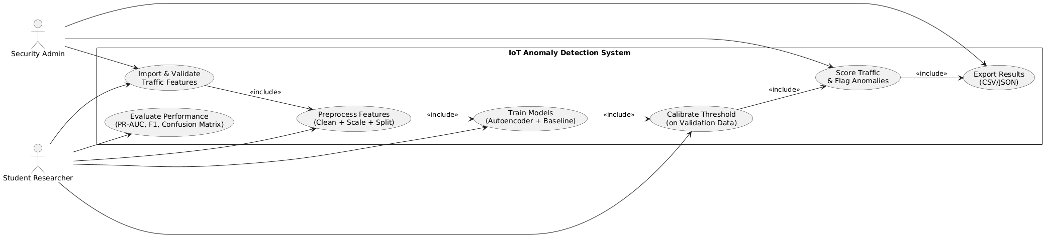
Use case diagram.

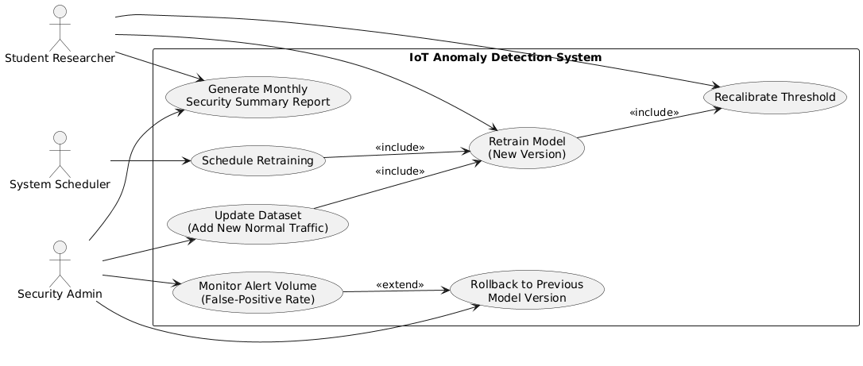

Functional requirements
The system should be able to read IoT traffic data from a structured file like CSV.
It should check if the input data match the expected format and clearly point out any missing or incorrect fields.
The system needs to clean the incoming data by applying a consistent approach for handling things like missing values.
It should normalise all features in a uniform way and save the settings used during this preprocessing.
The data should be split into training, validation and test sets using a method that gives the same result every time its run.
The system must train an autoencoder based model to detect anomalies using the training data.

Nonfunctional requirements
When using the same data, settings and random seed, the system should always produce the same results and data splits.
The exported results should be easy to read and understand with clear columns names and explanations.
The system should be able to finish scoring within a reasonable time even when running on a normal student laptop and using full size datasets.
The code should be organised into separate parts and tasks like preprocessing, training, scoring and evaluation and be well documented making it easier to update or fix issues.
If the data is not correct or incomplete it should not crash and it should show helpful error messages as well
The system should avoid storing sensitive data where possible and should stick to using public benchmark datasets – unless proper consent is used to find real traffic data.

Success criteria
The entire pipeline – from data input to exporting results – should work automatically without needing someone to step in
Both the autoencoder and at least one baseline model must be trained and evaluated using the same data split
The final report should show key metrics and include one visual aid like a confusion matrix or precision – recall curve.
The system must produce an export file that includes anomaly scores / flags and unique identifiers like record ID’s or timestamps.
The report should have an analysis of any errors made ad well as two suggestions for improving the system based on the analysis.
All experiments should be repeated, and the system must record settings and seeds so results can be recreated exactly.

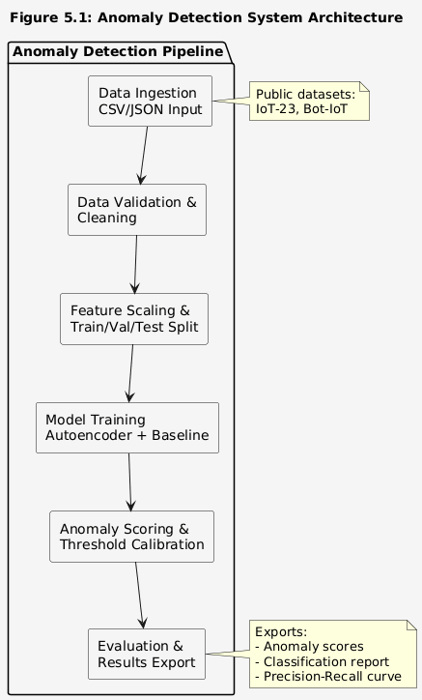
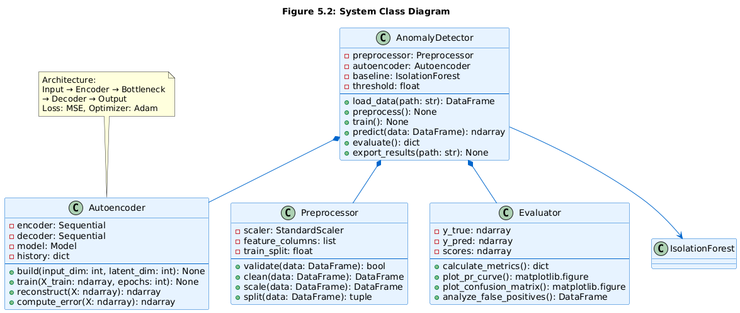
Solution design

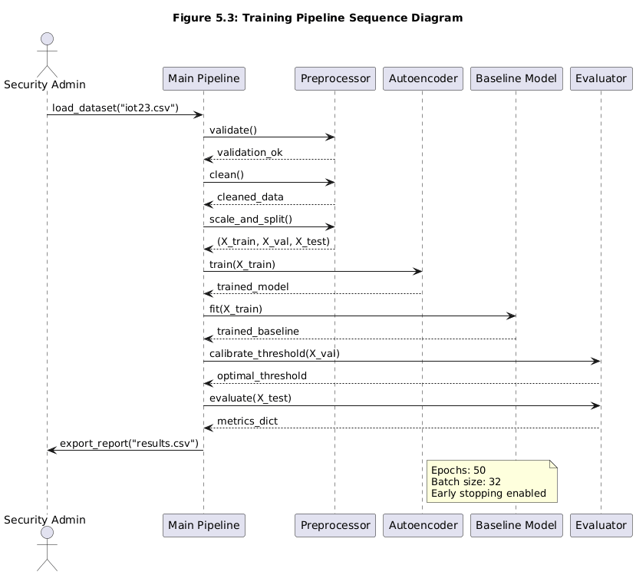

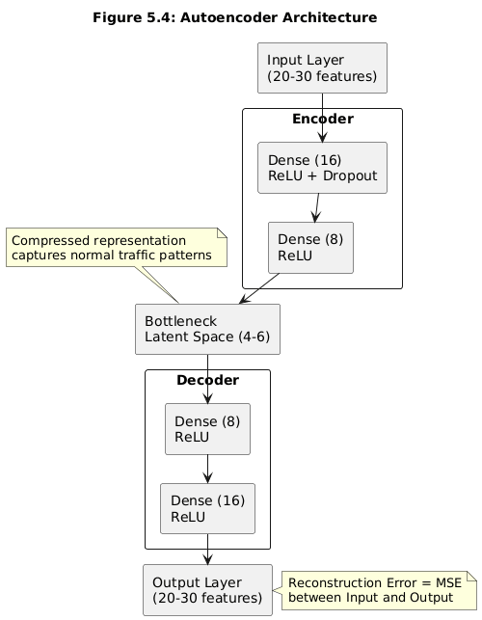
Neutral Network Architecture Diagram

Solution implementation
Give a detailed account of how you have created your artefact. You are recommended to divide this section up so that it matches your project plan, for example by describing the work you did in each sprint.
Consider choosing a particular technical challenge that you faced in each sprint and providing some detail (backed by evidence) of how you solved the challenge. Only include code snippets for particularly challenging parts of your implementation.
This section is all about your experience and therefore should be easy to write! Prepare for this by keeping a detailed log of all your activities and using your GitHub commits descriptively.

Solution testing/ evaluation

This is an important section where you weigh up the strengths and weaknesses of your artefact.
Guidance: If your project has a user-facing element, we expect to see some kind of evaluation of this with representative intended users, for example a ‘think aloud’ usability test.
You can also apply standard metrics for the domain you are working in and see how you have done against them. Your project does not have to be perfect -- indeed the outcomes might have been bad. The point is you must evaluate the outcome and discuss its strengths and weaknesses.

Discussion

This is a key section in which you summarise your findings, compare them to the findings of similar studies and draw conclusions about what your research has revealed.
Tie your discussion to specific evidence or activities that you have gathered and included in earlier sections of your report.

Conclusion

Summary
Briefly summarise your activities and findings.

Recommendations for further work
In this section, list some activities that you would undertake to improve your project if you had more time. Make sure these are realistic and based in evidence from your evaluation section.

Reflection
Finally, critically reflect on the entire project process and how well you have worked on the project. What things have you learned during the project? Why were you able and unable to meet project goals? What would have you had done differently in hindsight? Write this section in the first person.

References
[1] M. Antonakakis et al., “Understanding the Mirai Botnet Understanding the Mirai Botnet,” 2017. Available: https://www.usenix.org/system/files/conference/usenixsecurity17/sec17-antonakakis.pdf?

[2] Y. Meidan et al., “N-BaIoT—Network-Based Detection of IoT Botnet Attacks Using Deep Autoencoders,” IEEE Pervasive Computing, vol. 17, no. 3, pp. 12–22, Jul. 2018, doi: https://doi.org/10.1109/mprv.2018.03367731.

[3] A. Chatterjee and B. S. Ahmed, “IoT anomaly detection methods and applications: A survey,” Internet of Things, vol. 19, p. 100568, Aug. 2022, doi: https://doi.org/10.1016/j.iot.2022.100568.

[4] K. DeMedeiros, A. Hendawi, and M. Alvarez, “A Survey of AI-Based Anomaly Detection in IoT and Sensor Networks,” Sensors, vol. 23, no. 3, p. 1352, Jan. 2023, doi: https://doi.org/10.3390/s23031352.

[5] Sebastián García, A. Parmisano, and Maria Jose Erquiaga, “IoT-23: A labeled dataset with malicious and benign IoT network traffic,” Jan. 2020, doi: https://doi.org/10.5281/zenodo.4743746.

[6] N. Koroniotis, N. Moustafa, E. Sitnikova, and B. Turnbull, “Towards the development of realistic botnet dataset in the Internet of Things for network forensic analytics: Bot-IoT dataset,” Future Generation Computer Systems, vol. 100, pp. 779–796, Nov. 2019, doi: https://doi.org/10.1016/j.future.2019.05.041.

[7] T. Saito and M. Rehmsmeier, “The Precision-Recall Plot Is More Informative than the ROC Plot When Evaluating Binary Classifiers on Imbalanced Datasets,” PLOS ONE, vol. 10, no. 3, p. e0118432, Mar. 2015, doi: https://doi.org/10.1371/journal.pone.0118432.

[8] F. T. Liu, K. M. Ting, and Z.-H. Zhou, “Isolation Forest,” 2008 Eighth IEEE International Conference on Data Mining, Dec. 2008, doi: https://doi.org/10.1109/icdm.2008.17.

[9] B. Schölkopf, J. C. Platt, J. Shawe-Taylor, A. J. Smola, and R. C. Williamson, “Estimating the Support of a High-Dimensional Distribution,” Neural Computation, vol. 13, no. 7, pp. 1443–1471, Jul. 2001, doi: https://doi.org/10.1162/089976601750264965.

[10] “Zeek Documentation — Book of Zeek (v7.1.0-rc1),” Zeek.org, 2019. https://docs.zeek.org/en/current/

[11] “1. What is Suricata — Suricata 7.0.1-dev documentation,” docs.suricata.io. https://docs.suricata.io/en/latest/what-is-suricata.html

Appendices
Appendices appear after references. Your appendices depend on the nature of your project. Do not assume people will read your appendices. Even if you direct them to do so in your main text, appendices are considered more information and should not be relied upon to understand your main body of work. Refer readers to an appendix using a phrase such as see Appendix A for further details.
The following documents must be included as references:
- Your Project Proposal poster
- Evidence of your use of a project management tool eg. screenshots
- A description of how to access any technical output. It is strongly recommended you use GitHub or something similar to do this.
- Your ethics form
- Your risk register
- Any important communications between you and external stakeholders -- please ensure confidential data is removed and communications anonymised.

